**GUNSLINGER PLAYER AID V0.3 BY MRTOF**

**Outline of play**

Program actions for up to 5 segments.

Resolve SERIOUS wounds.

Resolve the 5 segments:

* When an action is revealed, the player must state how he will resolve it.
* On the same segment, shots are resolved first, then defense actions, then attack actions. All other actions actions are resolved afterwards.
* All effects only apply at the end of the segment.

If delay > life points, character falls unconscious.

Remove half (rounded up) DELAY points.

Remove smoke markers.

Result cards are reshuffled into the deck.

**Movement**

Actions: Advance, Run, Sprint, Back-Up, Turn, Spin Around, Get Up/Down, Leap/Drop

Character loses aim if he resolves any movement action except Turn.

Half a hex counts as 1 for movement.

**Terrain**

|  |  |
| --- | --- |
| Boardwalk, corner, door: | No effect |
| Steps: | No effect when walking from steps to stage or vice versa |
| Move into a hex with one other character or more: | 1 delay card |
| Window, fence, slope, bank | 2 delay cards when crossing |
| Obstacle* | 2 delay cards when entering and when leaving** |
| Forge, well: | Death |
| Tree trunk, wall: | No entrance (2 delay cards) |

*: Any hex without a coordinate, or a coordinate with an asterisk is an obstacle.

**: No effect when moving from one obstacle to another.

**Weapon handling**

Actions: Draw (pick-up)

2 handed weapons can only shoot when in Both Hands.

1 handed weapons can shoot when in any or Both Hands.

Moving a weapon from Both Hands to One Hand or dropping a weapon is free. Dropping a cocked weapon fires it.

Fanfiring is in Both Hands only.

**Line of Sight**

Trace Line of Sight from coordinates

If a character is adjacent to an obstacle and Down, the Line of Sight is blocked.

Doors and characters block Line of Sight.

**Shooting**

Actions: Cock/Aim/Shoot, Shoot, Load

Aim is lost after resolving any shooting action.

Aim can be moved by one hex (or to a character in a hex) when an Aim action is resolved.

Half a hex counts as ½ a hex for shooting range.

**Line of Fire**: Draw a card for every non target in the path of a shot. The aim time is one. All BE hits are SIDE hits.

**Smoke**: Place a smoke marker in hex when a gun fires. Smoke adds one to the range.

**Malfunctions**: On the first Malfunction result, check the “Handloaded” line. If the gun misfires draw again. If second draw is also a Malfunction, apply Second Draw line.

**Range factors** (D2, D3 or D4): If AIM time is 4 or more, divide range (rounding down) by range factor (the W44s only requires an AIM time of 2 to provide the bonus).

**Shotguns** (B5, B7): The shooter's hex in included in the blast pattern. Resolve shot for every character in blast pattern. Shotgun Bonus p= Range (+1 for B5). The final Aim time for the target = Shotgun Bonus + Aim points. The AIM time for all other characters in the blast pattern = Shotgun Bonus. Cross index Shotgun Bonus on IMPACT table. All shotgun BE hits are converted to CRIT hits.

**Double Action**: -1 AIM time but can be shot without being cocked.

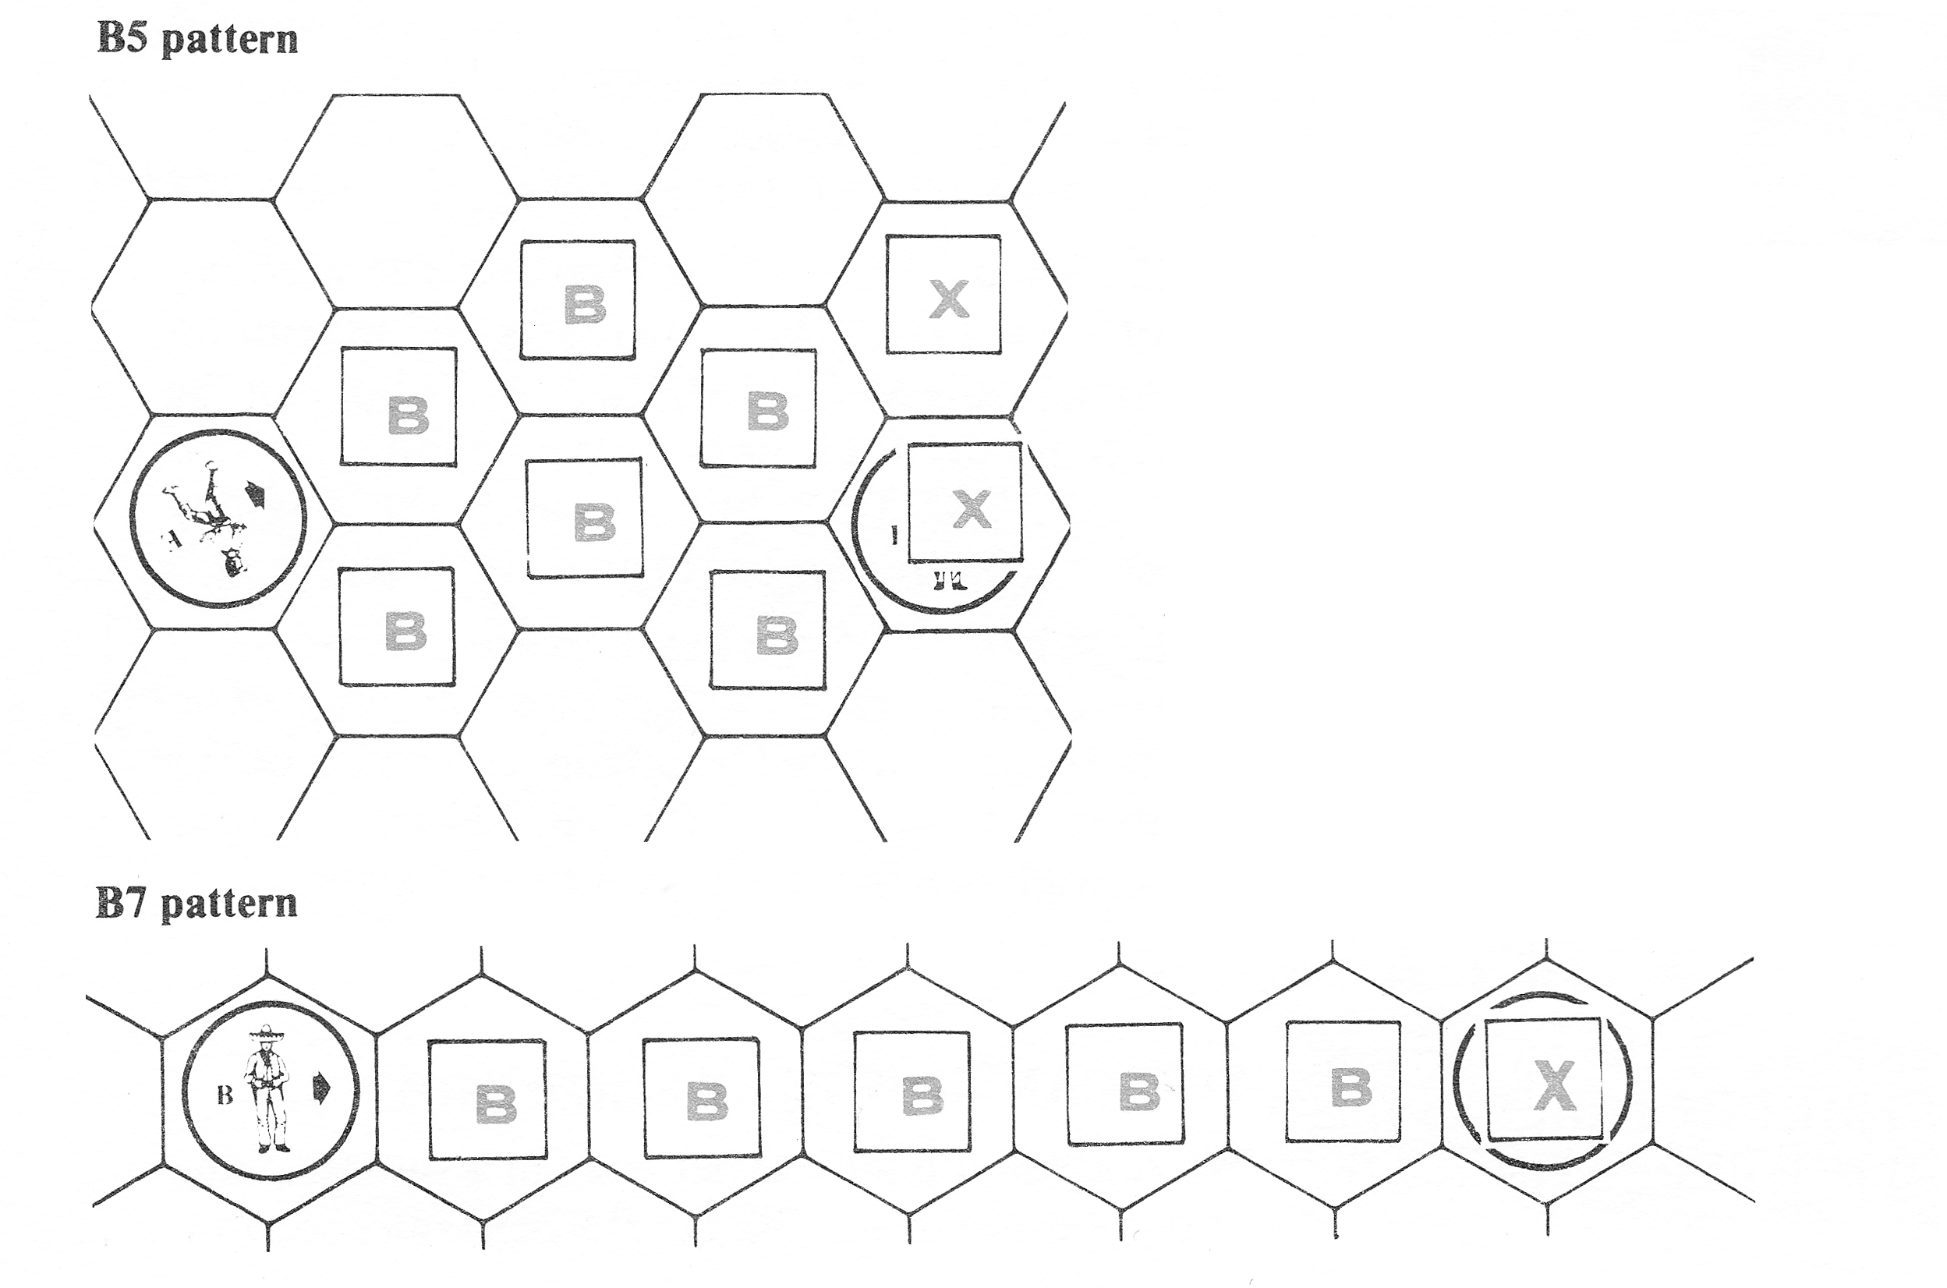**Double Barrel** (R10, R10s and R41d): A Cock action readies both barrels. When Firing, select either a single or both barrels. If both barrels are selected, resolve separately.

**Reloading**

Actions: Load

Normal (Circle): Load one ammunition per Reload action

Cap and Ball (Triangle): Load one ammo per 3 Reload Actions.

Breakopen: Reload once to open. Reload again to reload up to 5 ammunition. Reload to close.

**Brawling**

Attack actions: Throw, Belt, Chop, Hook, Jab, Kick, Lock, Bear Hug

Defense actions: Coverup, Duck, Side Step, Block, Guard, Trip, Hip Throw

**Strength**: Adds to wielding or adds to damage

When a brawling action is revealed all AIM markers are lost.

AIM time is equal to the weapons wielding (Bare Hands = 5)

**Throwing**

Throw actions: Throw

The weapon's wielding is the range that weapon can be thrown.

Strength can increase wielding.

If the weapon misses, draw a direction card.

**Head**

Actions: Head Out/Back

Line of sight is traced from the head counter's hex.

A character's aim zone is defined by his body and not his head.

The head counter is removed immediately if it exits a character's aim zone or if the character changes hex.

A head is always considered to be an “upright counter” and can be put around corners.

A character can pick up a weapon in his head counter's hex.

When firing, must shoot from head with a +1 range penalty.

When targeted, either head or body can be selected. +1 range penalty to fire at a head.

**Hunting**

If a character does not see or is not seen by an enemy during a turn, he becomes a hunter. If he sees an enemy or if he is seen by an enemy and that enemy shoots, throws or attacks, he stops being a hunter at the end of the turn.

A hunter must always have at least 2 activities recorded. The last recorded activity must always be PAUSE. Target hexes must be recorded for every activity.

Activities:

MOVE: move one hex on segment 3 (no turning)

LOAD, UP/DOWN, DRAW: resolved on segment 3

RUN: if upright, move one hex on segment 3 and another on segment 5 (turn to face next hex in route). Must follow a path

AIM: resolved on segments 3 and 5

FACING, HEAD: resolved on segment 3 or 5

PAUSE: must pause for at least 3 turns

